Anthropometry and Proxemics

in Interior Design

Interior design is more than just aesthetics, it’s about creating functional, comfortable, and meaningful spaces that cater to human needs. Two critical concepts that significantly impact interior design are **anthropometry** and **proxemics**. Understanding and applying these principles ensures that interior spaces are both practical and aesthetically pleasing. This article explores these concepts, their importance, and their application in interior design.

# What is Anthropometry

Anthropometry is the study of human body measurements and proportions. It focuses on the dimensions, reach, movement, and physical capabilities of people, which influence the design of spaces, furniture, and fixtures.

# The importance of Anthropometry in Interior Design

Anthropometry play a crucial role in Interior Design, by ensuring that spaces and furnishings are tailored to human dimensions and capabilities. Without considering anthropometric data, Interior Spaces may become uncomfortable, inefficient, or even hazardous. By incorporating precise measurements, designers can enhance user experience, maximise functionality, and create ergonomically sound environments that cater to a diverse range of users. SPecifically:

1. **Ergonomics and Comfort:** Furniture and fixtures designed using anthropometric data ensure user comfort, preventing strain and discomfort.
2. **Functionality:** Spaces planned with accurate body measurements enhance usability, ensuring ease of movement and interaction.
3. **Safety:** Proper spatial planning minimises risks related to tripping, reaching, and navigating the space.
4. **Universal Design:** Incorporating diverse anthropometric data accommodates different body types, ages, and abilities, promoting inclusivity.

Fig 1. Wikipedia (nd) Leonardo Da Vince, Vitruvian Man

# Application of Anthropometry in Interior

Design

Applying anthropometric principles in interior design ensures that furniture, spaces, and architectural elements meet the needs of users efficiently. By using anthropometric data, designers can create practical and adaptable solutions that enhance usability and accessibility while maintaining aesthetic appeal. What to consider:

1. **Furniture Design:** Tables, chairs, countertops, and cabinets are designed based on standard body measurements for optimal use.
2. **Space Planning:** The width of corridors, doorways, and clearance around furniture must accommodate comfortable movement.
3. **Workstations:** Desks, chairs, and computer setups are adjusted for proper posture to reduce strain.
4. **Storage Solutions:** Shelves and storage compartments are positioned within an accessible range to minimise effort and risk.

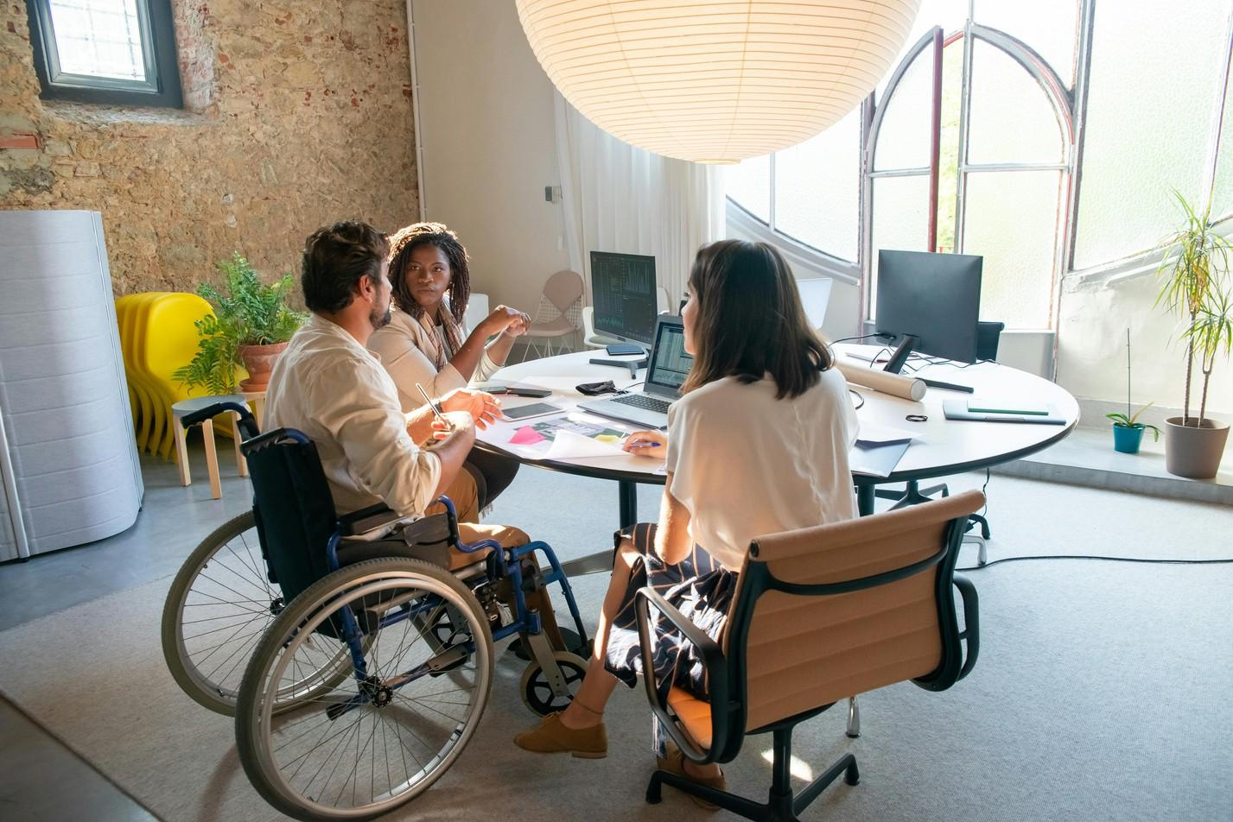

Fig 2. Pexels (2020), People Having a Meeting at the Office.

# What is Proxemics

Proxemics, introduced by anthropologist Edward T. Hall, is the study of how people use space in different contexts. It examines the impact of personal space, cultural norms, and social interactions on spatial arrangements.

# The importance of Proxemics in Interior Design

The arrangement of space in interior design greatly influences human behaviour, interaction, and comfort. Proxemics ensures that spaces are designed in a way that respects personal boundaries and social expectations. By understanding how people interact with their surroundings and with each other, designers can create environments that enhance communication, privacy, and overall spatial experience.

In Proxemics, here are some things to keep in mind:

1. **Enhancing User Interaction:** Thoughtful space planning influences communication and social interaction in a room.
2. **Psychological Comfort:** Well-defined spaces provide a sense of security, privacy, and ownership.
3. **Cultural Sensitivity:** Understanding cultural variations in spatial preferences ensures that designs respect social norms. and cultural backgrounds
4. **Efficiency in Layouts:** Proper spacing between elements prevents overcrowding and allows seamless movement.

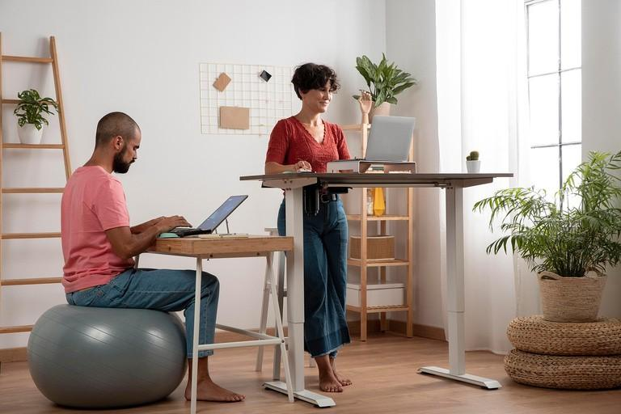

Fig 3. Pexels (2024): Person in Blue Denim Jacket Holding White Printer Paper

# Application of Proxemics in Interior Design

Applying proxemics in interior design helps create environments that balance openness, privacy, and social interaction. By understanding how different spatial arrangements affect human behaviour, designers can craft layouts that foster comfort, engagement, and efficiency.

1. **Residential Spaces**: Living rooms and dining areas are arranged to foster interaction, while bedrooms maintain privacy.
2. **Office Layouts:** Workspaces are designed with collaborative zones and quiet areas based on personal space preferences.
3. **Retail and Commercial Design:** Stores balance product displays with adequate walking space to avoid a congested feel.
4. **Public Spaces:** Parks, museums, and waiting areas incorporate seating arrangements that align with proxemic principles to ensure comfort and engagement.

# How Anthropometry and Proxemics afect

aesthetics in Inerior Design

Although it may sound counter intuitive, as one would say that having to folow certain ratios, dimensions and measurements, as dictated by Anthropomtery or Proxemics, would clearly affect the aesthetic aspect of an Interior Space, this isn’t necessarily true. While Anthropomntry ensures functionality, Proxemics enhances spatial experience—both contributing to the overall aesthetics of a space. Here’s how:

1. Balanced Proportions: Furniture and architectural elements sized appropriately create a visually harmonious environment.
2. Flow and Movement: Strategic placement of objects, considering human scale, ensures an intuitive and aesthetically pleasing layout.
3. Open vs. Intimate Spaces: Proxemics determines whether a space feels airy and open or cozy and enclosed, shaping its atmosphere.
4. Cultural Expression: Design elements inspired by proxemics create environments that align with specific cultural aesthetics and social interactions.
5. Personalisation and Comfort: Spaces designed with anthropometrics in mind allow for customisation, making them more visually and functionally appealing.

Anthropometry and proxemics are fundamental to interior design, influencing both the practicality and visual appeal of spaces. By integrating these principles, designers create environments that cater to human needs, improve interactions, and enhance the overall experience. A well-designed space is one that not only looks beautiful but also supports and enriches the lives of its occupants.

**2. Workspaces and Offices**

With the increasing demand for productivity and efficiency, ergonomic design has become essential in workspaces. Whether it’s a home office or a corporate setting, an ergonomically designed workspace helps reduce fatigue, improve concentration, and minimise health risks. Adjustable desks, chairs with lumbar support, and proper lighting contribute to a comfortable work environment that allows individuals to focus and work efficiently without experiencing discomfort or stress. What to consider:

**Desks and Chairs:** Adjustable chairs with lumbar support and desks at appropriate heights prevent posture-related health issues.

**Lighting:** Natural and artificial lighting should be balanced to reduce eye strain.

**Technology Placement:** Screens should be at eye level, and keyboards and mice should be positioned to avoid wrist strain.